50
CUIVRE ISLAND

HABITAT REHABILITATION AND ENHANCEMENT PROJECT

Pool 26
Upper Mississippi River Miles 233-239

Lincoln and St. Charles Counties, Missouri
St. Louis District

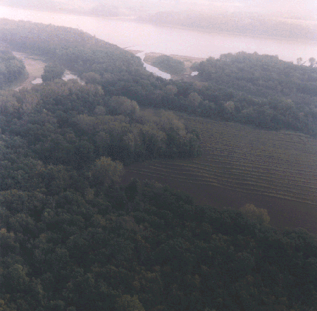

RESOURCE PROBLEM:

The primary problem in the upper reach of Pool 26 is that the chutes, sloughs, backwater areas, and wetlands have declined in depth and quality due to sedimentation. Approximately 90 acres of wetland/slough habitat will be created on the mainland adjacent to the Cuivre River.
PROJECT FEATURES:

- Install a water control structure at the lower end of Cuivre Island;

- Clean out interior ditches and install 7 drainage structures;

- Construct 6 hard points in Cuivre Slough;

- Notch existing closing dam in Phelan Island Slough; and

- Propwash dredge the lower end of Turkey Chute.

PROJECT OUTPUTS:

The water control structure, ditch cleanouts, and drainage structures will provide valuable habitat for fish. The closing dam notch and propwash dredging will increase flow down Cuivre Slough and provide adequate depths in Turkey Chute for fisheries.

FINANCIAL DATA:

General design costs are estimated at $358,000, and construction costs are estimated at $1,167,000. In accordance with Section 906(e) of the 1986 Water Resources Development Act (Public Law 99-662), general design and construction costs would be shared on a 75% Federal/25% non-Federal basis. The non-Federal sponsor, the Missouri Department of Conservation, will assume all annual operation, maintenance, and repair costs on State-owned lands, estimated at $14,700.

STATUS:

The project was approved for construction in September 1995. The construction contract was awarded in September 1997.

